… Canola oil VS Soybean oil …

0. Basic Information

*Canola Oil*

0. Contract size: 10 metric tons

1. Pricing unit: Yuan/ton

2. Minimum fluctuation: 2 Yuan/metric ton

3. Tick Size: 20 Yuan/metric ton

4. Commission: 2 Yuan/contract

*Soybean Oil*

0. Contract size: 10 metric tons

1. Pricing unit: Yuan/ton

2. Minimum fluctuation: 2 Yuan/metric ton

3. Tick Size: 20 Yuan/metric ton

4. Commission: 2.5 Yuan/contract

1. First glance

*About Data*

Data source: TDX

Range: Jan 16 2014 - Aug 29 2014

Frequency: 5 minutes

*Descriptive statistics*

Canola

Basic Statistical Measures

Location Variability

Mean 6894.619 Std Deviation 355.34962

Median 6998.000 Variance 126273

Mode 7236.000 Range 1476

Interquartile Range 570.00000

Soybean

Basic Statistical Measures

Location Variability

Mean 6758.414 Std Deviation 312.41742

Median 6852.000 Variance 97605

Mode 7082.000 Range 1376

Interquartile Range 449.00000

Normality

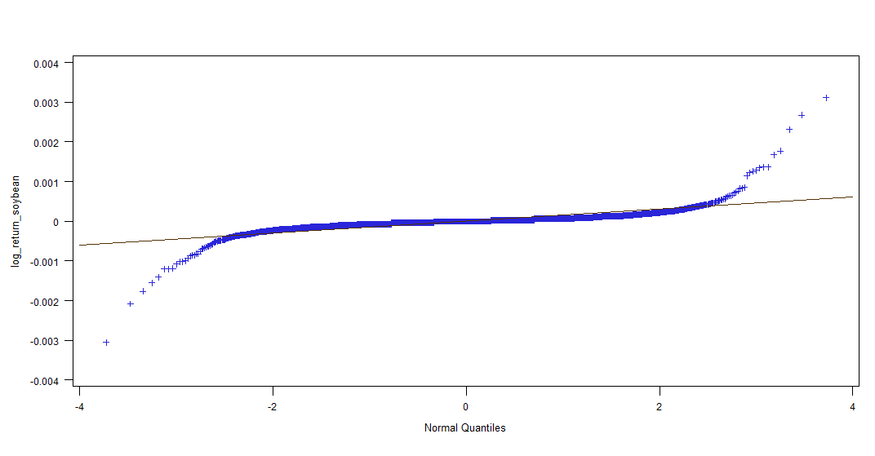 soybean logreturn? Yes 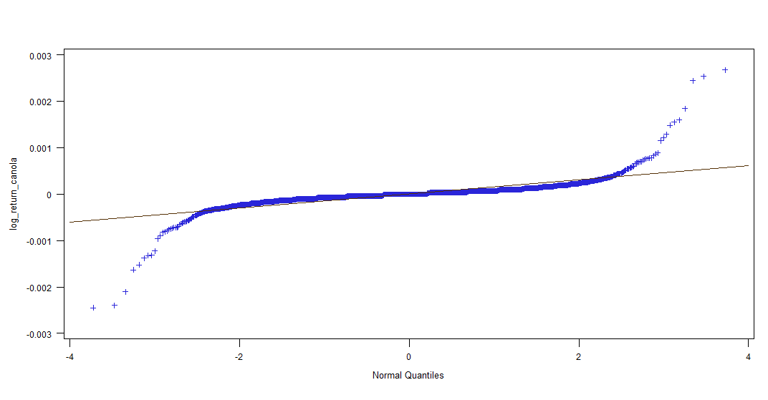 canola logreturn? Yes

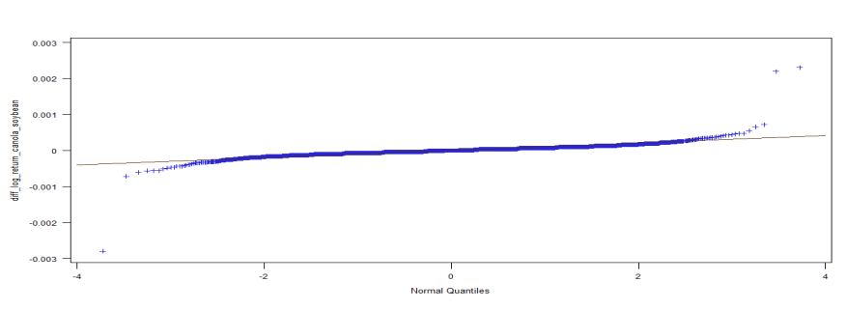 difference of logreturn? Yes.

Correlated?

Canola vs soybean: 0.98675

Return_canola vs return_soybean: 0.89862

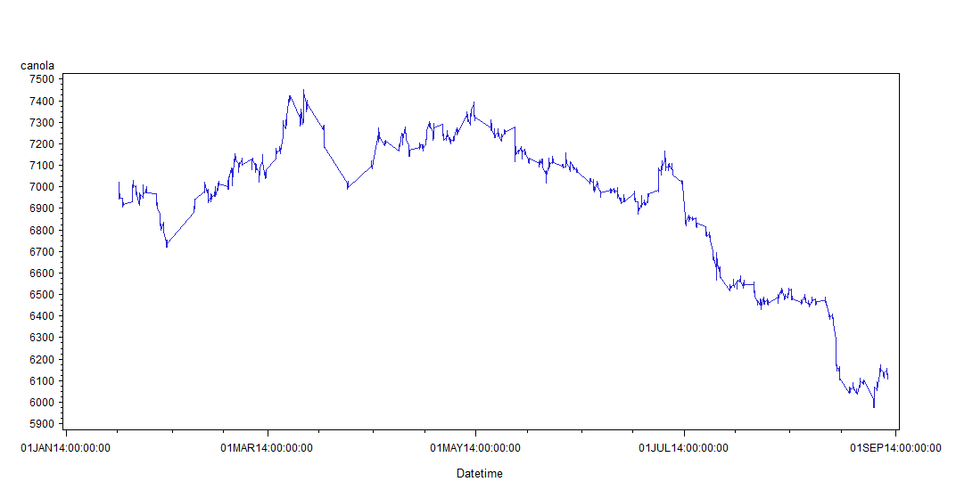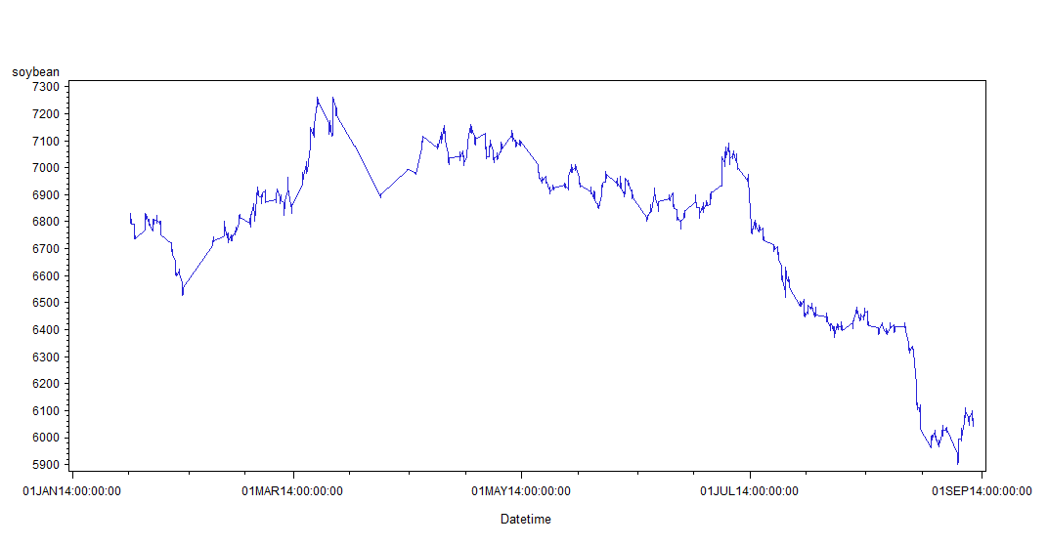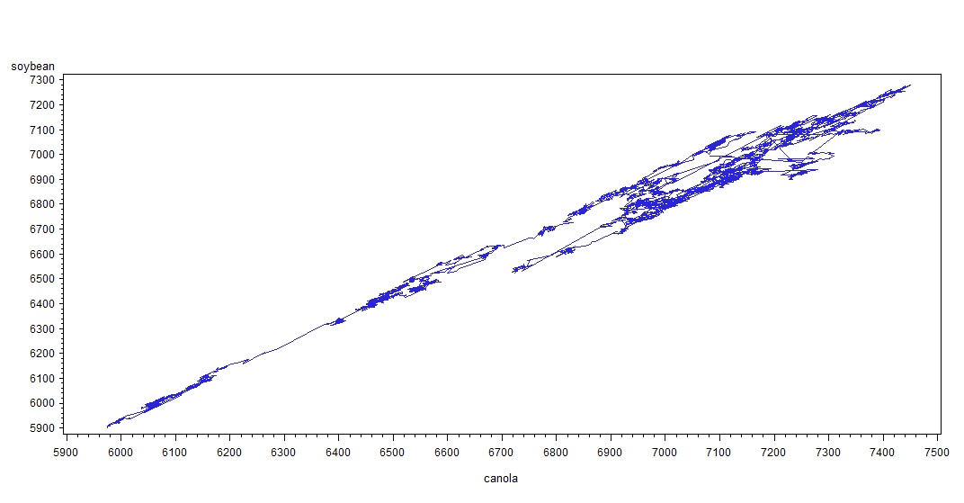

Weak stationary?

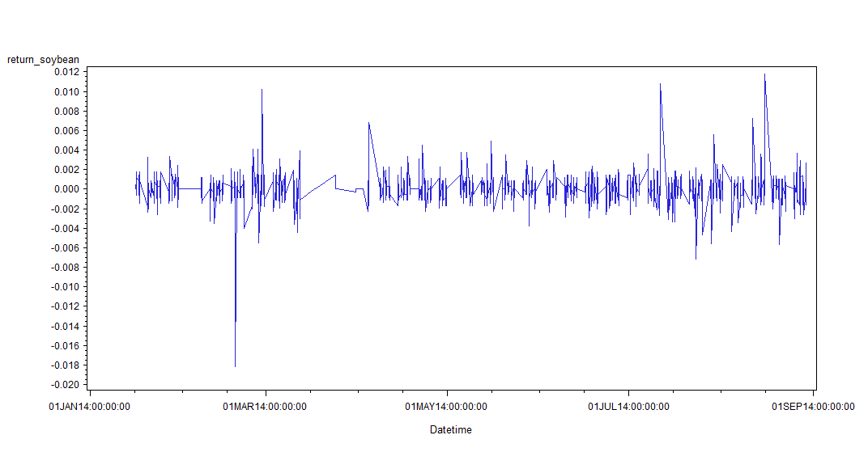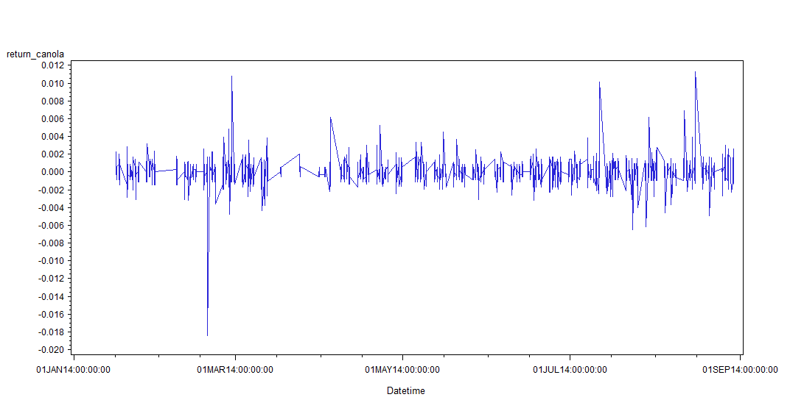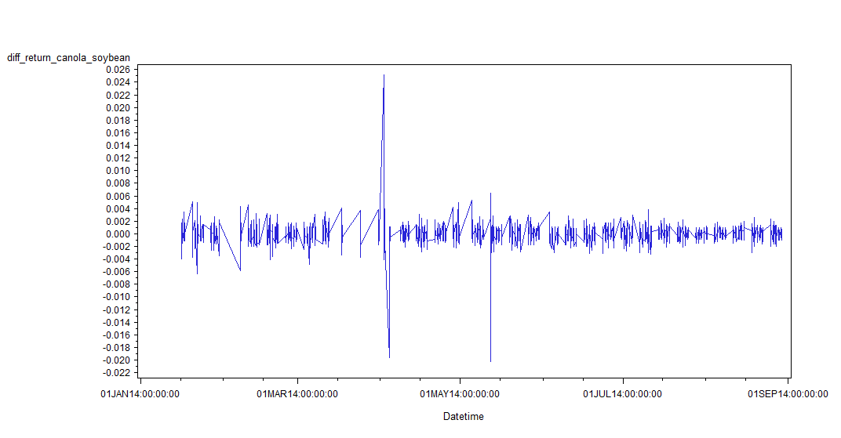

If we omit the outliers that are larger than 0.01 in absolute value.

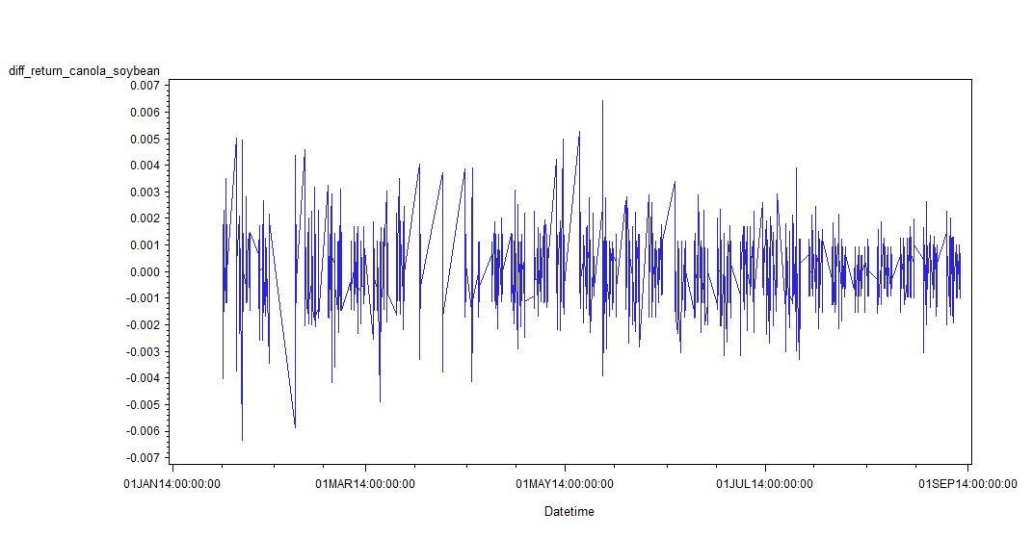

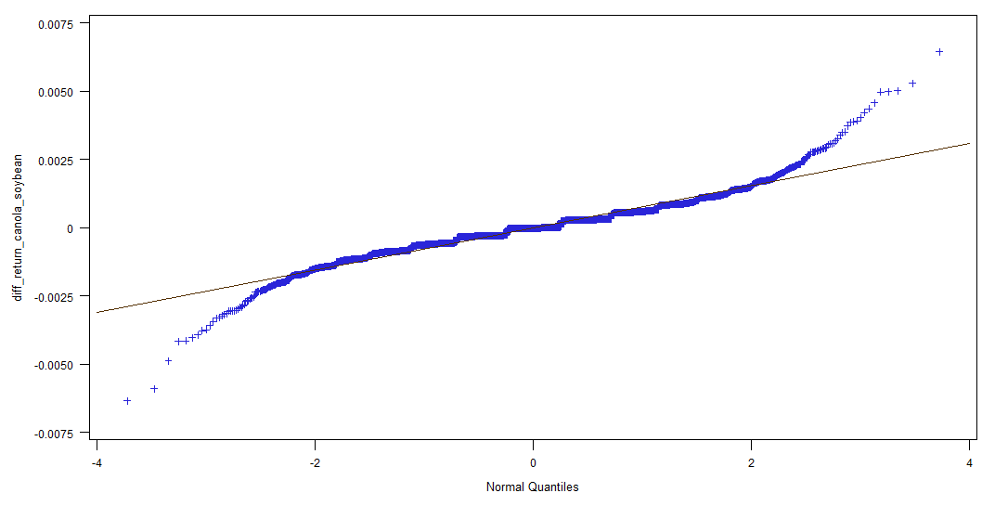normal?

2.Strategy

How frequently we trade?

When the band of diff_return_canola_soybean goes out of certain level, we bet on the mean reversion of it. But what band we shall use as our threshold level? We test it by Bootstrap (see the attached Python code). The result goes like:

when band= 0.0 ,you can make 0.999842370744 trade.

when band= 0.0001 ,you can make 0.805327868852 trade.

when band= 0.0002 ,you can make 0.804539722573 trade.

when band= 0.0003 ,you can make 0.605611601513 trade.

when band= 0.0004 ,you can make 0.478404791929 trade.

when band= 0.0005 ,you can make 0.477301387137 trade.

when band= 0.0006 ,you can make 0.326607818411 trade.

when band= 0.0007 ,you can make 0.258039092055 trade.

when band= 0.0008 ,you can make 0.25551702396 trade.

when band= 0.0009 ,you can make 0.16235813367 trade.

when band= 0.001 ,you can make 0.133354350567 trade.

when band= 0.0012 ,you can make 0.0832282471627 trade.

when band= 0.002 ,you can make 0.0225409836066 trade.

when band= 0.003 ,you can make 0.00725094577554 trade.

when band= 0.004 ,you can make 0.00283732660782 trade.

when band= 0.005 ,you can make 0.00126103404792 trade.

when band= 0.0252 ,you can make 0.0 trade.

What about unbalanced band?

Maybe not, we have 2995 negative diff_return and 2976 positive diff_return, and mean of negative value is -0.00058651349783, mean of positive value is 0.000596693403226, which are both less than minimum fluctuation, 1, for the contracts.

Stratified bands?

Doable, if we use 0.001, 0.002,0.003, we make one pair trade contract(buy canola and sell soybean oil or vice versa), 2 contracts for 0.002, 3 contracts for 0.003.

So finally?

When diff_return ( return_soybean_oil - return_canola_oil) is larger than 0.1% in every 5 minutes. We sell soybean oil and buy canola oil, and vice versa. Notice, this is feasible when the volatility is not a smirk (time it takes to raise is the same as the time it takes to fall), which is our case!

3. Simulated trading?

We use this strategy to trade just a contract(sell soybean and buy canola or vice versa), with the historical data on python. The result shows that we earn 1846 ticks, which equals 18460 Yuan, provided we make 809 trades. The commission fee is 809*2 = 1618 Yuan. 5% margin, equals 7000 Yuan. Notice, we can do better by choosing stratified bands, e.g., when the band is .2%, we trade two contracts.